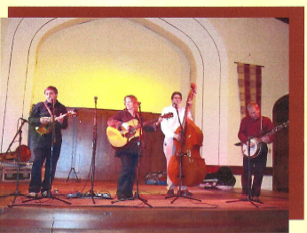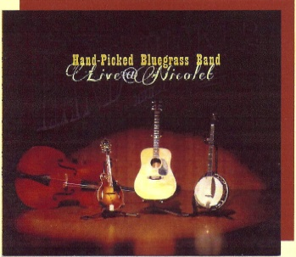

The Hand Picked Bluegrass Band is a high energy accoustic band playing everything from the traditional “high lonesome sound” of Bill Monroe to the exciting sounds of today’s progressive bluegrass groups – as well as their own original music. Hand Picked has the individual experience and desire to provide the polish and irresistible performance that is guaranteed to leave listeners connected and entertained. The band is very fortunate to have great pickers and singers who make it all work. Joe Cronick (banjo/mandolin/guitar); Brian Cate (upright bass); Sue Cronick (guitar/fiddle); Ron Meier (banjo/mandolin/guitar).

Hand Picked Bluegrass Band delivers a show of steller picking and powerful vocal arrangements. HPBB has performed at numerous festival events and opened for groups including The Chapmans, Rhonda Vincent, Martha & Eddie Adcock, James King, Bobby Osborne, the Gibson Brothers just to name a few. With such a high caliber lineup, you can be sure that each and every performanced will be a special one!

**Select Festivals and Concert Appearances:**

Picking In the Pines Festival, Rosholt WI

Minnesota Bluegrass & Old Time Festival

Northwoods Bluegrass Festival, Ladysmith, WI

Northern Indiana Bluegrass Association

Nicolet College – Rhinelander WI

East Troy Bluegrass Festival – East Troy, WI

Chestnut Center for the Arts – Marshfield, WI

LCO Casino – Hayward, WI

Concerts in the Park – various communities

North Star Casino, Bowler, WI

***Hand Picked’s music is featured on Mad Dog & Merrill’s Midwest Grill’n television show***

**Pleased to announce the**

**release of its newest project,**

**“Live @ Nicolet”**

**Receiving oustanding reviews!**

*Meet the Hand Picked Bluegrass Band…*

***Available to entertain at your upcoming event!***

**For bookings and information contact: Releases:** “Do What You Gotta Do”

Joe Cronick 715-966-6463 mailing: N12002 Rice Rd, Tomahawk, WI 54487 “Sweet Virginia”

Email: [handpickedbluegrass@charter.net](mailto:handpickedbluegrass@charter.net) “Live @ Nicolet”

Web: myspace.com/handpickedbluegrass or handpickedbluegrass.net